How to Distinguish Between Male and Female Fruit Flies

Steps
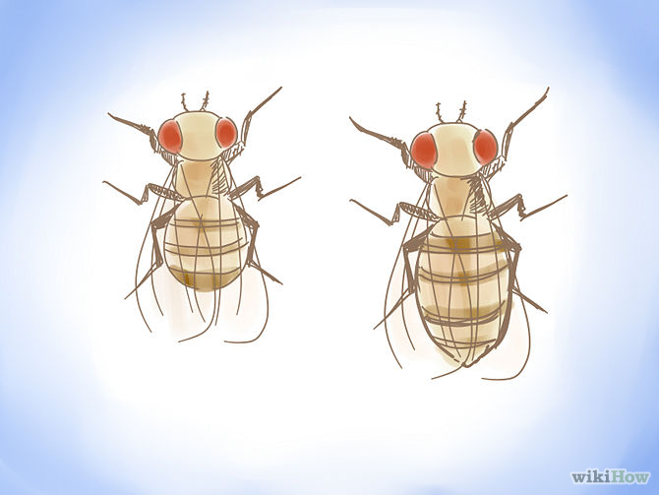
- Look at the size of the fly. This is the first and most basic step towards distinguishing the gender of your Drosophila. Female flies tend to be much larger than male flies. If you look at the cartoon above, you can see that the female is about 25% larger than the male. This method is not always foolproof, so you have to be willing to look a little deeper into the differences.
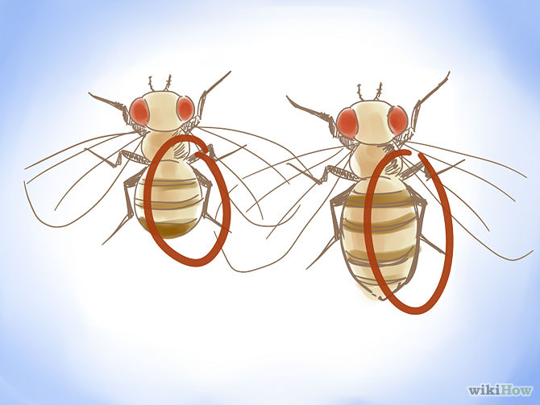
- Look at the color of the abdomen. A fly's abdomen is made up of many different segments. On a male fly, the last two segments of the abdomen are much darker than the female. The males have thick black bands, whereas the females tend to have one darker band on the bottom with a lighter band on top of that.
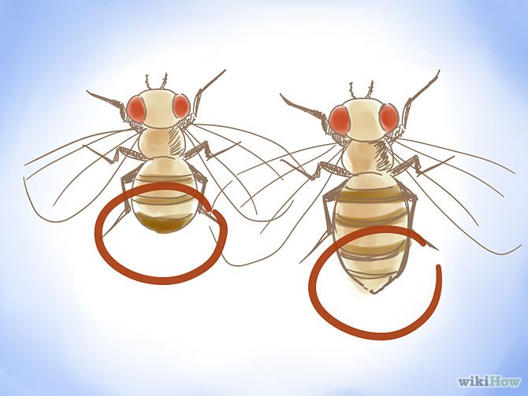
- While you're looking at the color of the last two segments of the abdomen, look at the shape of it. The male's abdomen is rounded at the bottom while the female's abdomen is pointed.
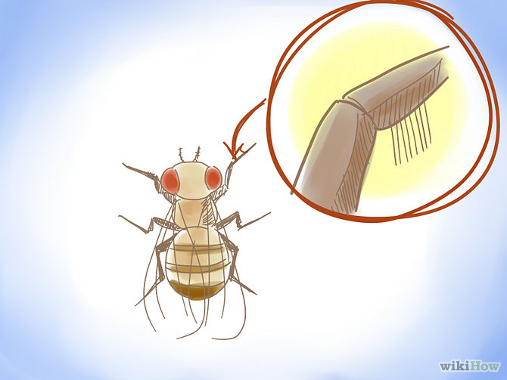
- Use a microscope to observe the sex combs. This is the best way to distinguish between males and females in that sex combs are always present. In order to see sex combs, you will likely need some sort of microscope. A basic 10x microscope will do. Sex combs are located on the forelegs of male flies and look like thick black lines right before the joint. If you look closer, you can see that they are raised a little bit off of the leg and pointed on the end.

This guide was adapted from a wikiHow article on the same subject. To access the online article, follow this link:
http://www.wikihow.com/Distinguish-Between-Male-and-Female-Fruit-Flies

